WEB TECHNOLOGY WITH UI UX
ASSIGNMENT 1 – TASK 1
NAME: HARVISHA SIDDHAPARA
CLASS: 4ITB BRANCH: IT

Step 1 - Click on New button to create a new repository 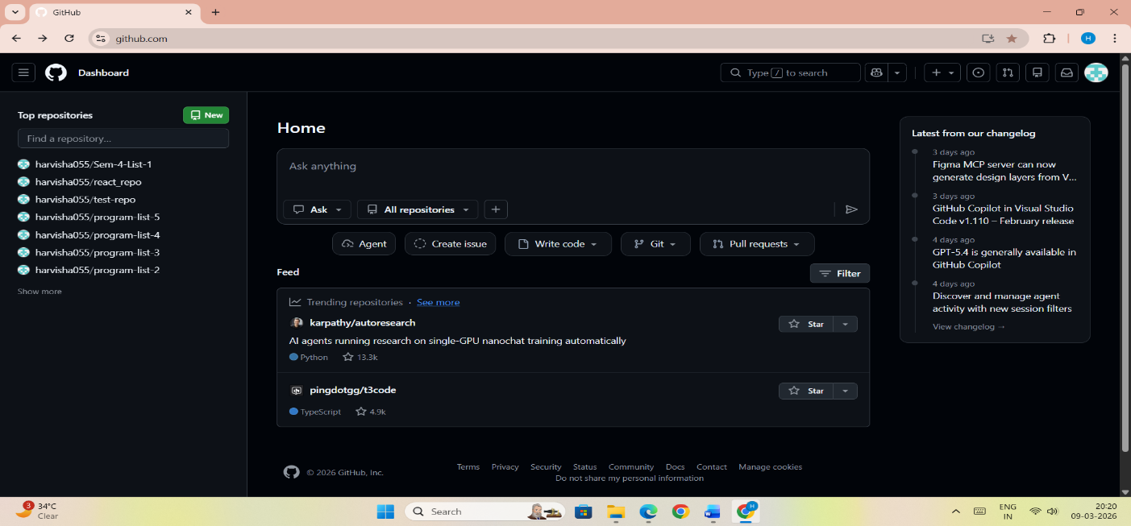

Step 2 - In the Repository name field, enter your enrollment number
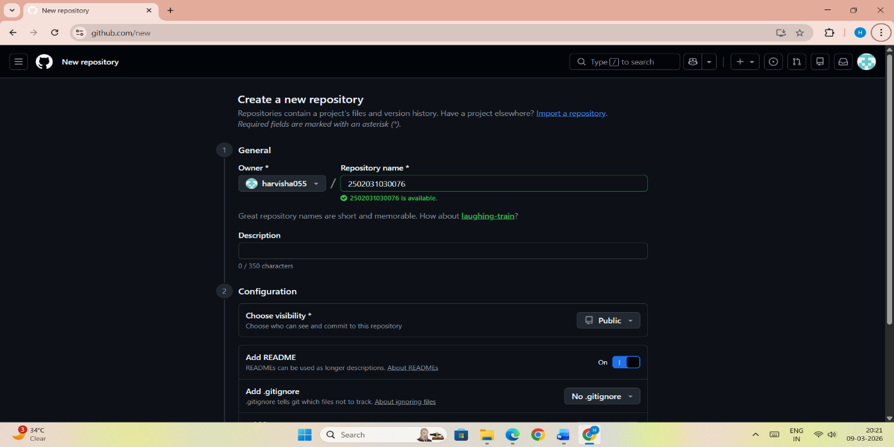

Step 3 - Click "Create repository".
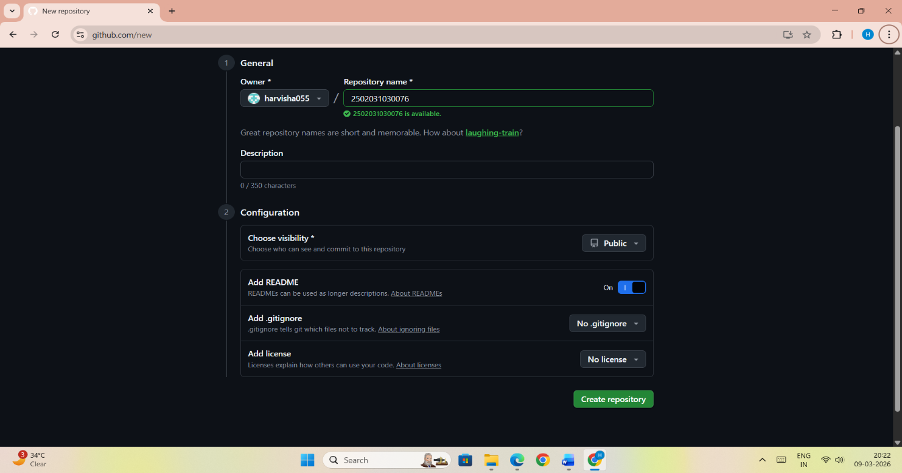

Step 4 - Click the "Add file" dropdown, select "Create new file
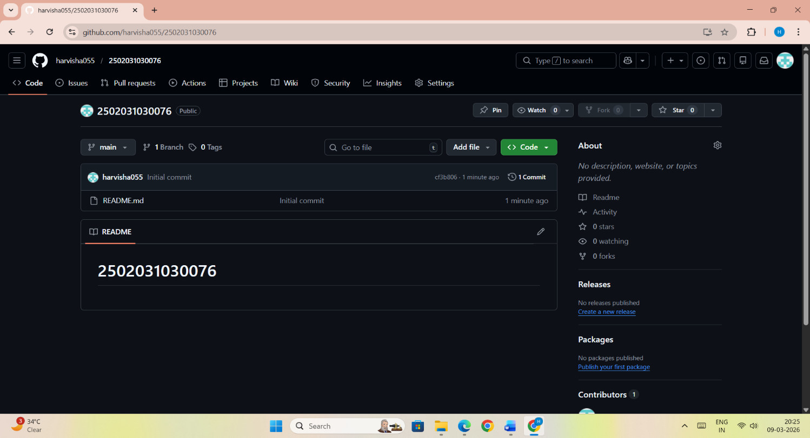

Step 5 - Type the folder name followed by a slash (/) to create the folder structure and click on commit changes.
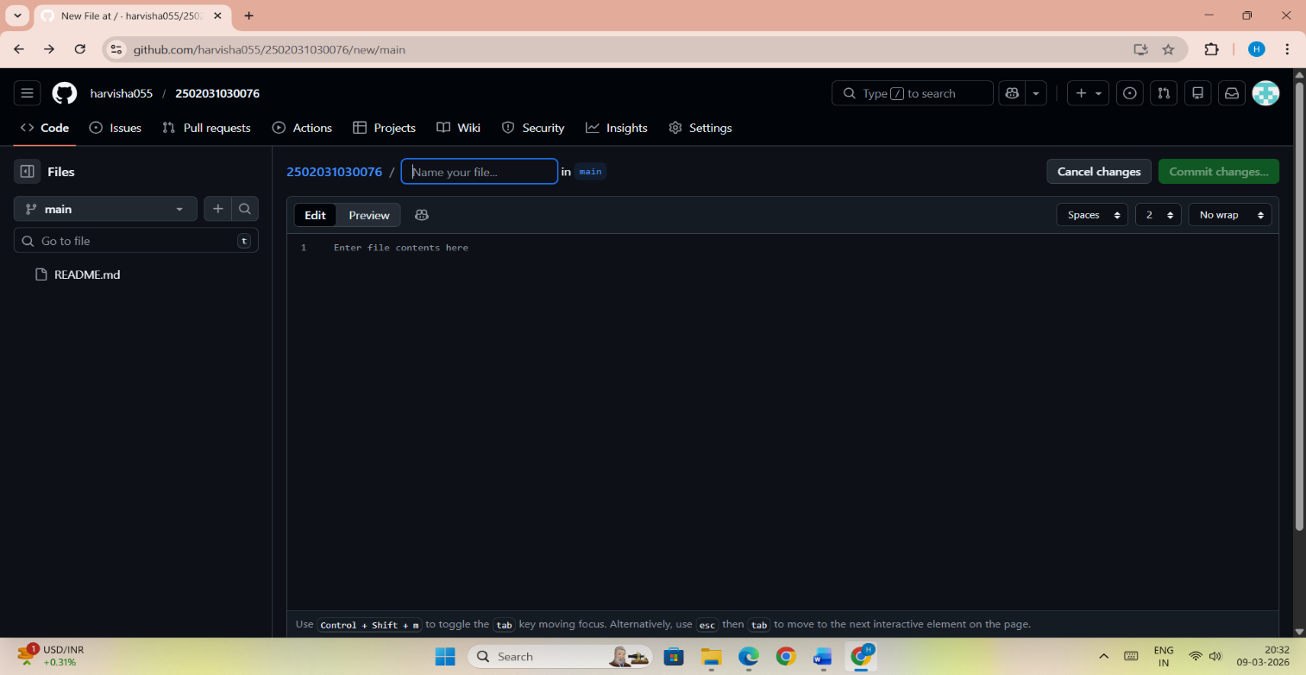

Step 6 – Assignment 1 folder created
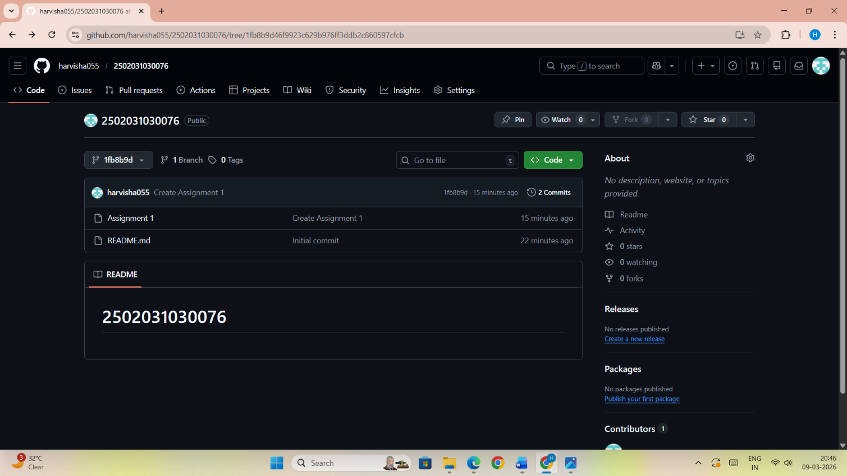

Step 7 – Add the file into the assignment 1 folder
